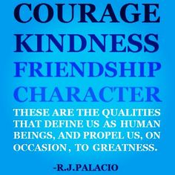

Name: Grade Level:

Original Precept:

What it means to you:
#EPCHSCHOOSEKIND

Return to Dr. Ward or Mrs. Hewitt by Oct. 14th

