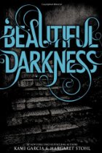

***Beautiful Darkness*** (Kami Garcia—2010 Little, Brown)

Ethan Wate used to think of his small Southern town as a place where nothing ever changed. Then one night in the rain, Ethan met and fell in love with Lena Duchannes and his life would never be the same. Lena is a Caster and her family is locked in a supernatural civil war full of darkness and demons. On her sixteenth birthday Lena made a terrifying choice, which now haunts her day and night. And as her seventeenth birthday approaches Lena and Ethan face even greater danger. A Caster and a Mortal can never truly be together. Every kiss is a curse and Ethan’s next heartbeat could be his last.

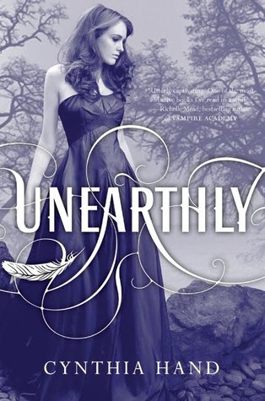

***Unearthly*** (Cynthia Hand—2011 Harper Collins)

Clara Gardner has recently learned that she is part angel. Being an “angel-blood” not only makes her smarter, stronger, and faster than humans, but it means she has a *purpose*, something she was put on this earth to do. Figuring out what that is, however, is not easy. Her visions of a raging forest fire and an alluring stranger lead her to a new school in a new town. When she meets Christian, who literally turns out to be the boy of her dreams, everything seems to fall into and out of place at the same time. As Clara tries to find her way in a world she no longer understands, she encounters unseen dangers and choices she never thought she'd have to make.



***Clockwork Angel*** (Cassandra Clare—2010 Walker Books)

When sixteen-year-old Tessa Gray begins a journey to England to find her brother, she soon discovers vampires, warlocks, and other supernatural beings are waiting for her in London’s Downworld. Tessa soon learns that she herself is a Downworlder with a rare ability: the power to transform into another person. Friendless and frightened, Tessa takes refuge with the Shadowhunters, who swear to find her brother if she will use her power to help them. She soon finds herself fascinated by, and torn between, her two best friends: James and Will. As their search draws them deep into the middle of a plot that threatens to destroy the Shadowhunters, Tessa realizes that she may need to choose between saving her brother and helping her new friends save the world...and that love may be the most dangerous magic of all.



***Hex Hall*** (Rachel Hawkins—2010 Hyperion Books)

When Sophie Mercer turned thirteen, she discovered that she was a witch. It's gotten her into trouble a few times. Her mortal mother has been super supportive, consulting Sophie's estranged father, an elusive European warlock, only when necessary. But when a prom-night spell goes horribly wrong, her parents send her to Hecate Hall, an isolated reform school for wayward witches. By the end of her first day among fellow freak-teens, Sophie has quite a scorecard: three powerful enemies who look like supermodels, a crush on a gorgeous warlock, and a new roommate, who happens to be the most hated person on campus. As a series of mysteries starts to converge, Sophie prepares for the biggest threat of all: an ancient secret society determined to destroy all witches, *especially* her.

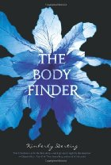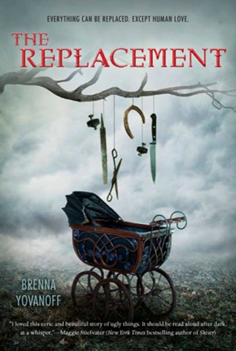

***The Body Finder*** (Kimberly Derting—2010 Harper Teen)

Sixteen-year-old Violet Ambrose has two major issues: Jay Heaton and her morbid secret ability. While she is confused by her new feelings for her best friend since childhood, she is more disturbed by her "power" to sense dead bodies—or at least those that have been murdered. Since she was a little girl, she has felt the echoes that the dead leave behind in the world...and the imprints that attach to their killers. Violet has never considered her strange talent to be a gift. But now that a serial killer has begun terrorizing her small town, and the echoes of the local girls he's claimed haunt her daily, she realizes she might be the only person who can stop him. Despite his fierce protectiveness over her, Jay reluctantly agrees to help Violet on her quest to find the murderer—and Violet is unnerved to find herself hoping that Jay's intentions are much more than friendly. But even as she's falling intensely in love, Violet is getting closer and closer to discovering a killer... and becoming prey herself.

***The Replacement*** (Brenna Yovanoff—2011 Penguin Books)

Mackie Doyle is not human. Though he lives in the small town of Gentry, he comes from a world of tunnels and black murky water, a world of living dead girls ruled by a little tattooed princess. He is a Replacement, left in the crib of a human baby sixteen years ago. Now, because of fatal allergies to iron, blood, and consecrated ground, Mackie is fighting to survive in the human world. He would give anything to live a normal life, to practice his guitar or spend time with his crush, Tate. But when Tate's baby sister goes missing, Mackie is drawn into the underworld of Gentry, known as Mayhem. He must face the dark creatures of the Slag Heaps and find his rightful place.