2014 Summer Reading – where history comes to life within the pages of a book.
Directions: Write your name under the title of the book you would like to read this summer. YOU CAN ONLY CHOOSE ONE.

Fiction Choices:
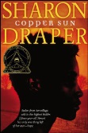 | 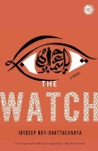 | 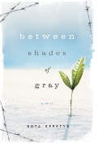 |  | 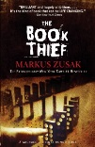
Copper Sun by, Sharon Draper | The Watch by, Joydeep Roy-Bhattacharya | Between Shades of Gray by, Ruta Sepetys | The Help by, Kathryn Stockett | The Book Thief by, Markus Zusak
When pale strangers enter fifteen-year-old Amari's village, her entire tribe welcomes them; for in her remote part of Africa, visitors are always a cause for celebration. But these strangers are not here to celebrate. They are here to capture the strongest, healthiest villagers and to murder the rest. They are slave traders. And in the time it takes a gun to fire, Amari's life as she's known it is destroyed, along with her family and village.  Beaten, branded, and dragged onto a slave ship, Amari is forced to witness horrors worse than any nightmare and endure humiliations she had never thought possible -- including being sold to a plantation owner in the Carolinas who gives her to his sixteen-year-old son, Clay, as his birthday present.  Now, survival and escape are all Amari dreams about. As she struggles to hold on to her memories in the face of backbreaking plantation work and daily degradation at the hands of Clay, she finds friendship in unexpected places. Polly, an outspoken indentured white girl, proves not to be as hateful as she'd first seemed upon Amari's arrival, and the plantation owner's wife, despite her trappings of luxury and demons of her own, is kind to Amari. But these small comforts can't relieve Amari's feelings of hopelessness and despair, and when an opportunity to escape presents itself, Amari and Polly decide to work together to find the thing they both want most...freedom. | Following a desperate night-long battle, a group of beleaguered soldiers in an isolated base in Kandahar are faced with a lone woman demanding the return of her brother’s body. Is she a spy, a black widow, a lunatic? Or is she what she claims to be: a grieving young sister intent on burying her brother according to local rites? Single-minded in her mission, she refuses to move from her spot on the field in full view of every soldier in the stark outpost. Her presence quickly proves dangerous as the camp’s tense, claustrophobic atmosphere comes to a boil when the men begin arguing about what to do next.  Told from various points of view, including those of the U.S. soldiers, Joydeep Roy-Bhattacharya’s heartbreaking and haunting novel takes a timeless tragedy and hurls it into present-day Afghanistan. Taking its cues from the Antigone myth, Roy-Bhattacharya recreates the chaos, intensity, and immediacy of battle, and conveys the inevitable repercussions felt by the soldiers, and their families, and especially one sister. The result is the most powerful expression to date of the nature and futility of war. | Lina is just like any other fifteen-year-old Lithuanian girl in 1941. She paints, she draws, she gets crushes on boys. Until one night when Soviet officers barge into her home, tearing her family from the comfortable life they've known. Separated from her father, forced onto a crowded and dirty train car, Lina, her mother, and her young brother slowly make their way north, crossing the Arctic Circle, to a work camp in the coldest reaches of Siberia. Here they are forced, under Stalin's orders, to dig for beets and fight for their lives under the cruelest of conditions.  Lina finds solace in her art, meticulously-and at great risk-documenting events by drawing, hoping these messages will make their way to her father's prison camp to let him know they are still alive. It is a long and harrowing journey, spanning years and covering 6,500 miles, but it is through incredible strength, love, and hope that Lina ultimately survives. | Twenty-two-year-old Skeeter has just returned home after graduating from Ole Miss. She may have a degree, but it is 1962, Mississippi, and her mother will not be happy till Skeeter has a ring on her finger. Skeeter would normally find solace with her beloved maid Constantine, the woman who raised her, but Constantine has disappeared and no one will tell Skeeter where she has gone.  Aibileen is a black maid, a wise, regal woman raising her seventeenth white child. Something has shifted inside her after the loss of her own son, who died while his bosses looked the other way. She is devoted to the little girl she looks after, though she knows both their hearts may be broken.  Minny, Aibileen's best friend, is short, fat, and perhaps the sassiest woman in Mississippi. She can cook like nobody's business, but she can't mind her tongue, so she's lost yet another job. Minny finally finds a position working for someone too new to town to know her reputation. But her new boss has secrets of her own.  Seemingly as different from one another as can be, these women will nonetheless come together for a clandestine project that will put them all at risk. And why? Because they are suffocating within the lines that define their town and their times. And sometimes lines are made to be crossed. | It is 1939. Nazi Germany. The country is holding its breath. Death has never been busier, and will become busier still.  Liesel Meminger is a foster girl living outside of Munich, who scratches out a meager existence for herself by stealing when she encounters something she can't resist-books. With the help of her accordion-playing foster father, she learns to read and shares her stolen books with her neighbors during bombing raids as well as with the Jewish man hidden in her basement.
Name: | Name: | Name: | Name: | Name:
ID: | ID: | ID: | ID:  TURN OVER FOR MORE CHOICES | ID:

Non-Fiction Choices:
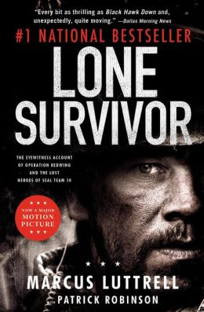 | 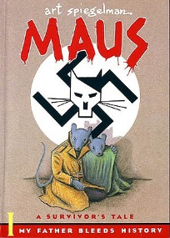 | 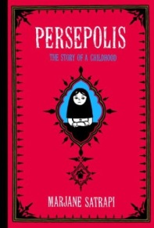
Lone Survivor by, Marcus Luttrell | Maus I by, Art Spiegleman | Persepolis by, Marjane Satrapi
On a clear night in late June 2005, four U.S. Navy SEALs left their base in northern Afghanistan for the mountainous Pakistani border. Their mission was to capture or kill a notorious al Qaeda leader known to be ensconced in a Taliban stronghold surrounded by a small but heavily armed force. Less then twenty-four hours later, only one of those Navy SEALs remained alive.  This is the story of fire team leader Marcus Luttrell, the sole survivor of Operation Redwing, and the desperate battle in the mountains that led, ultimately, to the largest loss of life in Navy SEAL history. But it is also, more than anything, the story of his teammates, who fought ferociously beside him until he was the last one left-blasted unconscious by a rocket grenade, blown over a cliff, but still armed and still breathing. Over the next four days, badly injured and presumed dead, Luttrell fought off six al Qaeda assassins who were sent to finish him, then crawled for seven miles through the mountains before he was taken in by a Pashtun tribe, who risked everything to protect him from the encircling Taliban killers.  A six-foot-five-inch Texan, Leading Petty Officer Luttrell takes us, blow-by-blow, through the brutal training of America's warrior elite and the relentless rites of passage required by the Navy SEALs. He transports us to a monstrous battle fought in the desolate peaks of Afghanistan, where the beleaguered American team plummeted headlong a thousand feet down a mountain as they fought back through flying shale and rocks. In this rich , moving chronicle of courage, honor, and patriotism, Marcus Luttrell delivers one of the most powerful narratives ever written about modern warfare-and a tribute to his teammates, who made the ultimate sacrifice for their country. | A memoir about Vladek Spiegleman, a Jewish survivor of Hitler's Europe, and about his son, a cartoonist who tries to come to terms with his father, his story, and with history itself. Cartoon format portrays Jews as mice and Nazis as cats. | Persepolis paints an unforgettable portrait of daily life in Iran: of the bewildering contradictions between home life and public life and of the enormous toll repressive regimes exact on the individual spirit. Marjane's child's-eye-view of dethroned emperors, state-sanctioned whippings, and heroes of the revolution allows us to learn as she does the history of this fascinating country and of her own extraordinary family. Intensely personal, profoundly political, and wholly original, Persepolis is at once a story of growing up and a stunning reminder of the human cost of war and political repression. It shows how we carry on, through laughter and tears, in the face of absurdity. And, finally, it introduces us to an irresistible little girl with whom we cannot help but fall in love.
Name: | Name: | Name:
ID: | ID: | ID:

