“The things I want to know are in books; my best friend is the man who’ll get me a book I ain’t read.” Abraham Lincoln

Directions: Write your name under the title of the book you would like to read this summer. You can only choose one.

 | 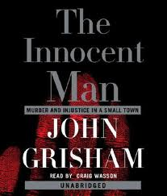 | 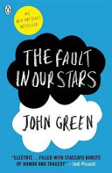
Perks of Being a Wallflower  By, Stephen Chbosky | The Innocent Man  By, John Grisham | The Fault in Our Stars  By, John Green
Standing on the fringes of life offers a unique perspective. But there comes a time to see what it looks like from the dance floor. This haunting novel about the dilemma of passivity vs. passion marks the stunning debut of a provocative new voice in contemporary fiction.  This is the story of what it's like to grow up in high school. More intimate than a diary, Charlie's letters are singular and unique, hilarious and devastating. We may not know where he lives. We may not know to whom he is writing. All we know is the world he shares. Caught between trying to live his life and trying to run from it puts him on a strange course through uncharted territory. The world of first dates and mixed tapes, family dramas and new friends. | In the town of Ada, Oklahoma, Ron Williamson was going to be the next Mickey Mantle. But on his way to the Big Leagues, Ron stumbled, his dreams broken by drinking, drugs, and women. Then, on a winter night in 1982, not far from Ron’s home, a young cocktail waitress named Debra Sue Carter was savagely murdered. The investigation led nowhere. Until, on the flimsiest evidence, it led to Ron Williamson. The washed-up small-town hero was charged, tried, and sentenced to death—in a trial littered with lying witnesses and tainted evidence that would shatter a man’s already broken life, and let a true killer go free. | Despite the tumor-shrinking medical miracle that has bought her a few years, Hazel has never been anything but terminal, her final chapter inscribed upon diagnosis. But when a gorgeous plot twist named Augustus Waters suddenly appears at Cancer Kid Support Group, Hazel’s story is about to be completely rewritten.
Name: | Name: | Name:
ID #: | ID#: | ID#:
OVER FOR MORE CHOICES

